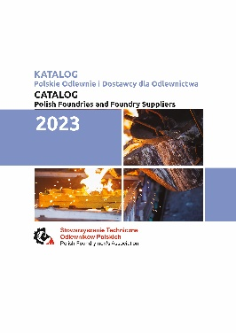
KATALOG
POLSKIE ODLEWNIE I DOSTAWCY DLA ODLEWNICTWA
CATALOG
POLISH FOUNDRIES AND FOUNDRY SUPPLIERS
2023

ORDER FORM
I am ordering the Catalog of Polish Foundries and Foundry Suppliers 2023
Form of the Catalog:
☐ pdf version
☐ printed version

COMPANY DETAILS TO ISSUE AN INVOICE
Name of company | Click here to insert the text
Address | Click here to insert the text
Tax number | Click here to insert the text

The filled order form should be sent by e-mail to zg@stowarzyszenie-stop.pl.
The catalog will be sent to the client after receiving the payment. Payment can be made only by bank transfer.
Price of the Catalog: 50 euro net for pdf version, 50 euro net + delivery costs for printed version .

